**Appendix. Intonational contours of several examples from different groups analyzed in Praat[1]**

(i) V-neg (all > not, total negation):

*Ne VER’TE vsem tem užasam, (kotorye rasskazyvaet padčerica o svoem otčime).*

not BELIEVE all those horrors (which tells stepdaughter about her stepfather)

‘Do not believe all those horrors that a stepdaughter tells about her stepfather.’

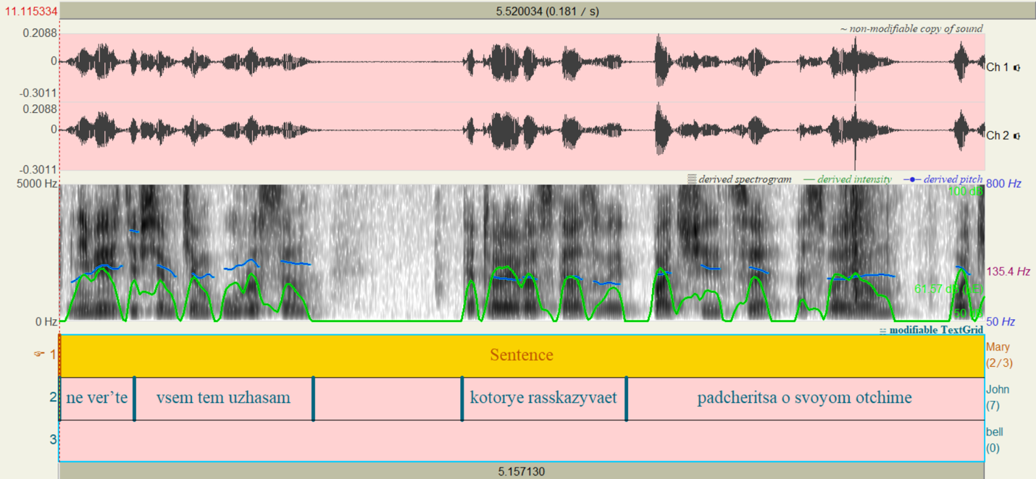

(ii) Q-neg (not > all, partial negation):

*Ja ne budu VSE cifry privodit'.*

I not will ALL figures to-give

‘I am not going to give (you) all the figures.’

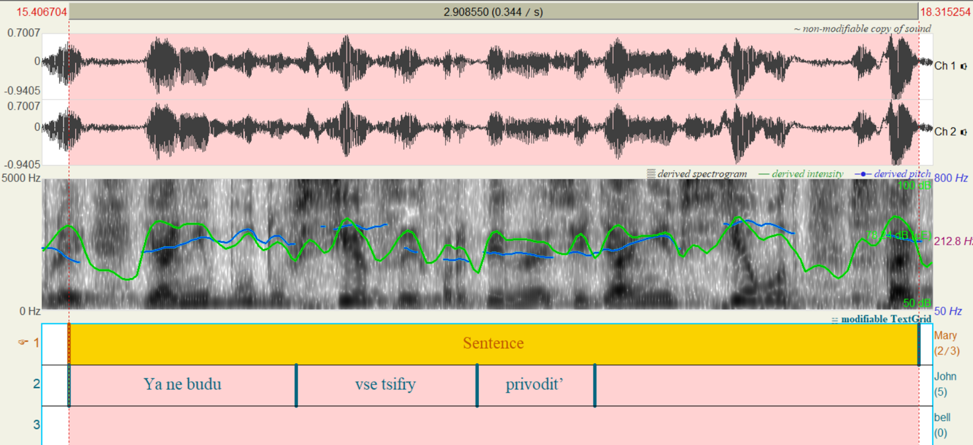

(iii) VP-neg (not > all, but quantifier is not the only element in the scope of negation):

*Ja ne SOBIRAJUS’ vsju žizn’ u tëtki na šee sidet’!*

I not INTEND all.ACC life.ACC at aunt.GEN on neck.LOC to-sit

‘I am not going to sponge off my aunt all my life!’ (I have other plans)

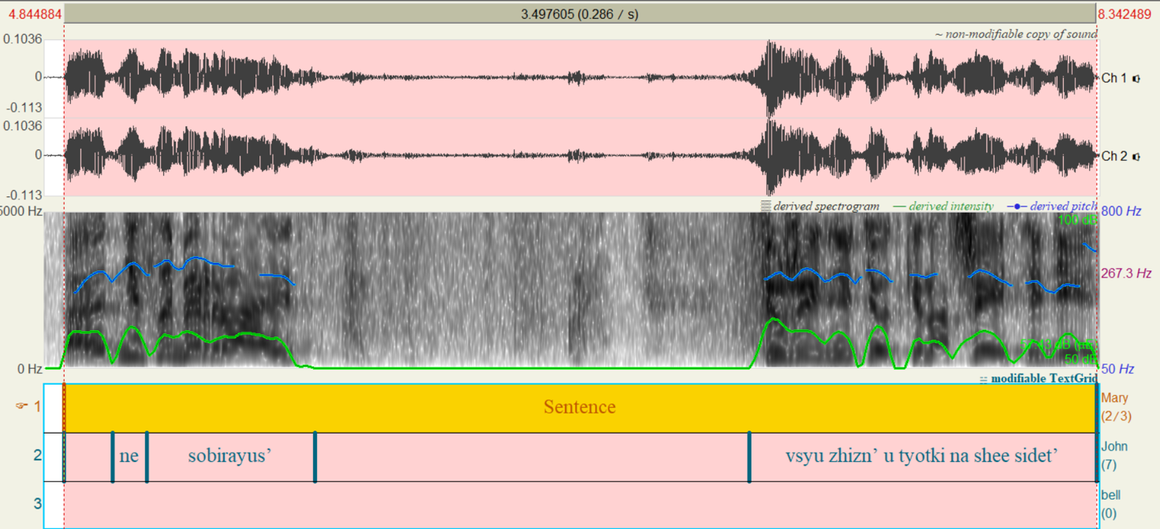

1. Boersma, Paul, and van Heuven, Vincent (2001). Speak and unSpeak with Praat. *Glot International*. 5: 341–347.